Learning to Cut, Bandage and Cure:
Histories of Surgical Training, Skills & Knowledge in Early Modern Europe

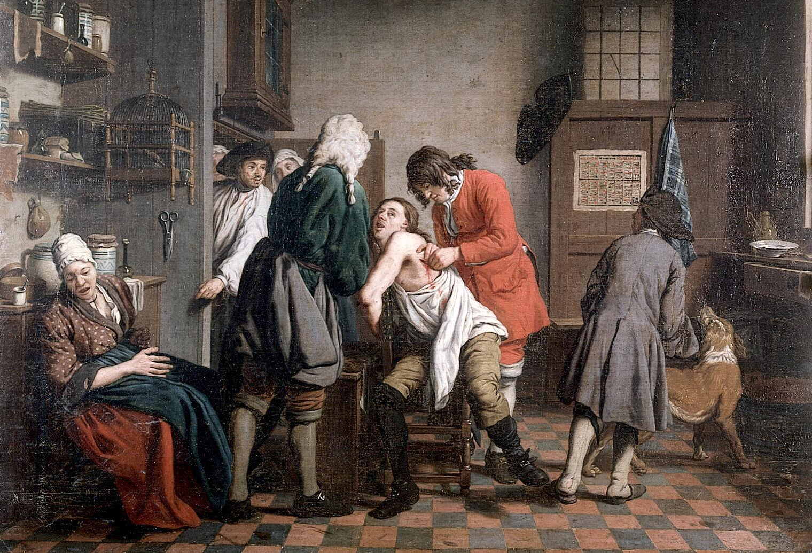

An international conference organised by Maria Pia Donato, Elaine Leong and Juliette Rigaud sponsored by Institut d’Histoire Moderne et Contemporaine (Paris) and University College London with the support of Translitterae PSL, ED540 Lettres, Arts et Sciences ENS, the Society for the Social History of Medicine, and Wellcome Trust (grant #209835/Z/17/Z).

23-24 September 2022
école Normale Supérieure
45, rue d’Ulm, 75005 Paris
Salle Dussane

In the past decades, historians of medicine and science have scrutinised early modern scholarly practices and book cultures, rediscovered genres of medical writing and reframed key issues concerning the relation between theory and practice. New thriving scholarship has delved into the production and transfer of medical knowledge, and has offered new histories on practices of bedside teaching and other forms of training. These research trends, however, have only tangentially touched upon surgery. Historians of surgery have instead largely focused upon mapping the contours of a very elusive occupational group. While excellent studies have illuminated medieval and renaissance learned surgery, the quotidian knowledge cultures of vernacular practitioners warrant further exploration. This is particularly the case for the 16th to 18th centuries, where little scholarly attention has been devoted to surgical education and training. Although scholars agree that surgery was a highly mobile activity, implying different skills and levels of literacy and learning, not much is known about how these were actually acquired by practitioners across their life-course, diverse as they were from the modest bloodletter to the university-trained surgeon. Moreover, the relationship of theory and practice in this branch of medicine that inherently featured a bigger role for manual intervention and was often characterised as the operative part of medicine, remains relatively unproblematized and to some extent still dependant on modern understandings of surgery. This conference aims to extend our understanding of surgical training and education across Europe c. 1500-1800 by examining books, images, instruments and other learning aids and charting their role in the transfer of know-how and skills.

Friday, September 23rd, 2022
9:45 Welcome: Maria Pia Donato, CNRS/IHMC

10:00-11:15 Chair: Sandra Cavallo, Royal Holloway, University of London

Surgery and the Artisanal Language of Techne: Leonardo Fioravanti’s Vernacular Readers
Cynthia Klestinec, Miami University

Learning to Operate in 1645 from a Medieval Manuscript
Peter Jones, University of Cambridge

11:15-11:30 Pause

11:30-13:30 Chair: Sophie Vasset, Université Paul-Valérie/IRCL

Learning from Disaster: Surgical Mishaps and Pedagogy
Heidi Hausse, Auburn University

Jan de Doot’s Self-surgery: Lithotomy, Surgical Passion, and First-hand Experience
Gideon Manning, Cedars-Sinai Medical Center

Learning Surgery Through Cases in Early Modern Italian Hospitals
Maria Pia Donato, CNRS/IHMC

13:30-14:30 Lunch break (on site)

14:30-16:30 Chair: Bruno Belhoste, Université Paris 1/IHMC

Learning To Bleed Through Bloodletting Figures
Jack Hartnell, University of East Anglia

Visualizing Knowledge and Surgical Training in Early Modern London
Elaine Leong, University College London

Books about Surgery and Books for Surgeons in Early Modern Spain
Sophie-Bérangère Singlard, Aix Marseille Université, CAER

16:30-16:45 Pause

16:45-18:45 Chair: Rafael Mandressi, CNRS/Centre Alexandre Koyré

Picturing Surgical Bodies in Baroque Rome: Guglielmo Riva’s Printed Tables as Teaching Tools
Silvia De Renzi, Open University

The License to Cut: Catholic Missionaries Learning and Practicing Surgery in Early Modern Rome and Beyond
Brendan Röder, Ludwig-Maximilians-Universität München

Surgery in the Early Modern Hispanic World: The Case of Pedro Gago de Vadillo
Mariana Sánchez, Université Paris Cité

20:00 Conference dinner for speakers

Saturday, September 24th, 2022

9:15-11:15 Chair: Elaine Leong, University College London

Body, Honour, Health and Hand-Work: Crafting Surgery in Print and in the City
Tillmann Taape, Warburg Institute London

Learning and Teaching Specialized Surgical Practice in the Holy Roman Empire:
Families, Workshops, Hospitals and Illustrated Manuscripts, 16th and 17th Century
Annemarie Kinzelbach, Universität Ulm

A Barber-surgeon and His Patients in Early 17th-century Germany
Michael Stolberg, Universität Würzburg

11:15-11:30 Pause

11:30-12:45 Chair: Marilyn Nicoud, Avignon Université/CIHAM

How to Become a Forensic Expert. Learning by Doing, Surgeons and Legal Medicine in Early Modern France
Cathy McClive, Florida State University

Surgical Textbooks Meet Legal Records: Instructing and Witnessing the Practice of Surgery in Early Modern Spain
Carolin Schmitz, King’s College London

12:45-13:45 Lunch break (on site)

13:45-15:00 Chair: Christelle Rabier, EHESS/Cermes3
« La liberté de pouvoir m’instruire » : François Humbert and Surgeons’ Apprenticeship Tales in 18th-Century France
Juliette Rigaud, ENS/ED540

Eighteenth-Century French Newspapers as Sites of Surgical Knowledge Production
Meghan K. Roberts, Bowdoin College

15:15 Conference ends
Illustration: Interior with a surgeon and his apprentice attending to a patient, peinture à l’huile, Jan Josef Horemans, 1722. Crédits : Wellcome Collection. Attribution 4.0 International (CC BY 4.0)

